# Prac 4 Part 2: Photosynthesis Report

**This assignment is marked out of 50 and will be converted to /10% of your final assessment for this unit.**

**1) Electronic Format**

The worksheet must be produced entirely in an electronic fashion. Hand-written or hand-drawn components, be they as original or scanned images, will not be accepted and not receive any marks. Submit electronically as either a **word or PDF file** via the designated assignment Turnitin dropbox in the Resources and Assessment folder on Moodle.

**2) Plagiarism and Collusion**

When you submit your work via the Turnitin dropbox, you will get a report showing the degree of similarity of you work to other sources of information e.g. Internet, published sources, fellow or past student’s work. Any degree of unexpected plagiarism or collusion found will be dealt with in accordance with the Academic Integrity Policy (see Deakin College website).

**3) Referencing**

All foreign sources of information, must be cited. The citation style to be used is Deakin-Harvard style, for more information about this style and referencing in general see: <https://www.deakin.edu.au/students/studying/study-support/referencing>.

Citations will be considered only when they are placed as in-text citations such that it is clear which statement they do support. Furthermore, bibliographic details of a citation must be provided in a reference list at the end of the document. The citation needs to be a quality journal article, book or refereed website. No marks are awarded if Wikipedia or poor-quality websites (eg. the website of a course at another institution) are cited.

***Citations of text books or journal articles are often most appropriate for the level of this unit and therefore encouraged. If you do cite a textbook, you must indicate relevant page numbers!***

**4) Formatting and general instructions**

Using the information provided in this document, you are expected to write a report of approximately 1600 words. Please note that figures, figure legends, headings, citations and references will not be included in the word limit. You should use an appropriate font in size 11/12, with double spacing and justified text. Appropriate section headings are recommended.

Answers to the concept map labelling task should be included at the start of your report on a separate page.

# Concept map of photosynthesis

Refer to the concept map below to answer these questions. (1 mark per question)

1. What is the chemical species that is transferred through the light reactions? (Box A)
2. What energy-rich compound is produced by the actions of the cytochrome complex? (Box B)
3. What is the compound (Box C) used to donate electrons to the photosystems, and which gives rise to 2H+ and O2?
4. What energy is used to energise the light reactions? (Box D)
5. What is the product of the reaction that is occurring at NADP+ reductase? (Box E)
6. Provide names for structures i and ii? (0.5 mark for each correct answer)
7. The electron-accepting dye, DCPIP, substitutes for which compound in your prac 4, part B experiment?

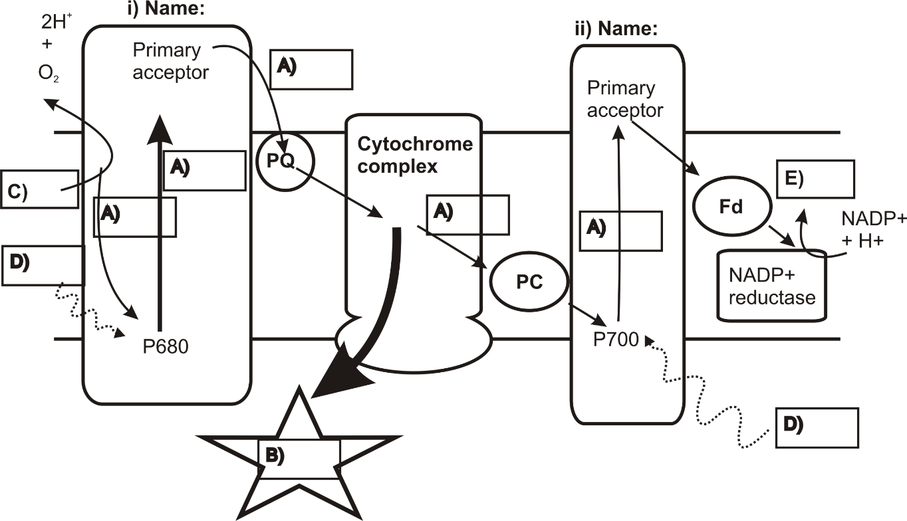

# Introduction

Provide a brief introduction to your experiment (~400 words). Use the following prompts and the concept map on the previous page to guide you. Provide an overview of photosynthesis by describing the purpose of the light and dark reactions. How do the light and dark reaction contribute to photosynthesis? Describe the products and by products of the light reactions and the general concept of the system. What part of the system does the DCPIP substitute? This section should include a statement of aim/purpose/hypothesis (5 marks).

# Methods

In one paragraph (~300 words), provide a description of your experimental procedure. Include a description of the experimental treatment and any controls. The purpose of the controls and the expected change in your measurement also need to be clearly described. Details of the buffer preparation do not need to be included if the original methodology is correctly referenced (5 marks).

# Results

Using the data your group collected in prac 4, produce a graph of absorbance against time using Excel. Include a suitable title, labelling of the x and y axes with appropriate units and a figure legend. Provide a figure legend/caption (in the box, below your graph) that concisely describes the graph that is shown and the experiment that underlies the measurements. A figure legend/caption does not reproduce the entire experimental procedures in detail, but rather puts the shown result into an experimental context (12 marks for graph, 6 marks for caption/legend). You should also include a results text (in addition to the figure legend). This should be approximately 200 words (4 marks).

# Discussion

Provide a discussion section linking your observed trend with the functioning of the light reactions in plants (~700 words). How does the amount of light received affect the light reactions of photosynthesis? (8 marks)

In this section you should address the following extension problem. Assume that you have set up another cuvette in the exact same way as your experiment. In this cuvette, you have also added a compound that blocks the conversion of water to oxygen (and therefore blocks the introduction of electrons to PSII). What do you think would happen to the absorbance in this experimental system? Two to three sentences (50 words or less) should be enough to answer this question. (3 marks)

# Reference list

A reference list should be provided at the end of your report. Your references should be in Deakin-Harvard format. Ensure that any in-text citations appear in your reference list (and vice-versa).